Automatic Night Lamp

Circuit diagram:

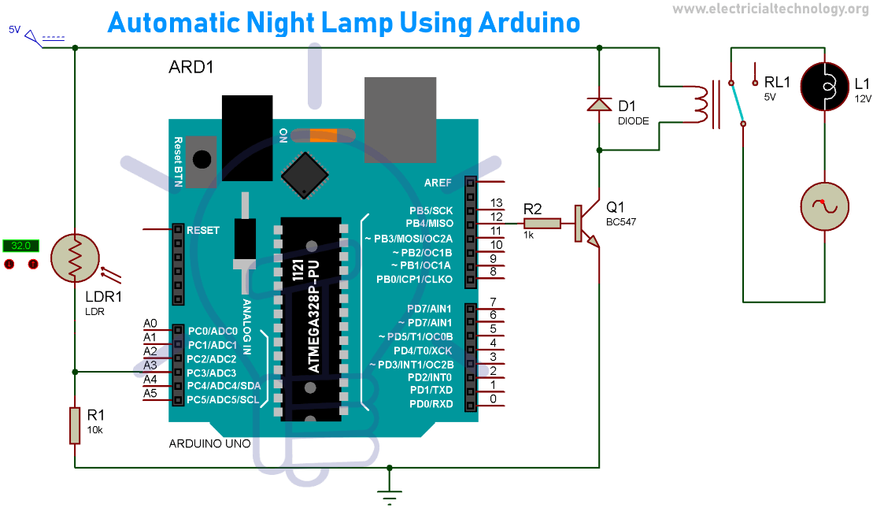

Theory:

CONCEPT USED:

➢ By using LDR Sensor

➢ By using different light conditions

➢ connection of different sensors

LEARNING AND OBSERVATIONS:

• Connections of LDR

• How to control LDR and its coding,uses.

OBSERVATION:

➢ LED glowing in dark only or visa-versa.

➢ Relation between software and hardware for LDR

PROBLEMS & TROUBLESHOOTING:

o To select the right port and type of arduino

o To check the loose connections

o To check the connections according to the codes

PRECAUTIONS:

o Handle LDR carefully

o Do not connect arduino till the circuit is complete

OUTCOMES:

o LEDs glows in a certain period of time

o It can be used as for decorating purpose